Off-axis THz Parametric Oscillator

Yu-Chung Chiu,¹ Tsong-Dong Wang,² Po-Cheng Wang,¹ and Yen-Chieh Huang ^{2,*}
¹ Institute of Photonics Technologies/Department of Electrical Engineering, National Tsinghua University, Hsinchu 30013, Taiwan
² Chung-Shan Institute of Science and Technology, Taoyuan 32546, Taiwan
*email: ychuang@ee.nthu.edu.tw

All the previously reported Terahertz (THz) parametric oscillators resonate the signal lasers red-shifted from the pump lasers, suffering from low parametric gain and high absorption loss for the generated THz waves. Here, we report a generic THz parametric oscillator that resonates a THz wave with a zigzag path in a pump-filled monolithic crystal. By pumping such an off-axis lithium-niobate oscillator with a pulsed Nd:YAG laser having an axial-mode spacing matched to the THz oscillator’s mode spacing, we generated an ultra-broad red-shifted frequency comb between 1065 and 1085 nm at the output, which corresponds to a 5-octave-spanning THz-frequency comb in the idler spectrum. We also demonstrated a signal-seeded off-axis THz parametric oscillator, which generates 90-W narrow-line radiation at 2.1 THz and achieved 46% pump depletion with only 4-mJ pump energy in a 460-ps pulse width.
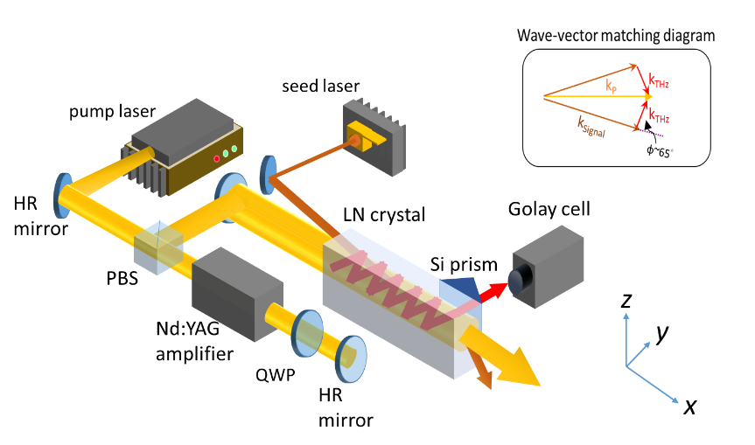

Yen-Chieh Huang

Current Position:
- Professor, Department of Electrical Engineering, NTHU
- Adjunct professor, Institute of Photonics Technologies & Physics Department, NTHU
Education
Jan. 1995, PhD, Electrical Engineering Department, Stanford University, USA
Jan. 1991, MS, Electrical Engineering Department, Stanford University, USA
Jan. 1987, BS, Electrical Engineering Department, National Sun Yat-Sen University
Experience:
- July 9, 2014, Feb. 9, 2015, visiting professor, Royal Institute of Technology (KTH), Stockholm, Sweden
- Jun. 5-25, 2014, visiting scientist, SLAC National Accelerator Laboratory, Stanford University
- Feb. 9~Aug. 15, 2009, visiting professor, Applied Physics Department, Stanford University
- Feb. 2007 ~ Jul. 2012, research fellow, National Synchrotron Radiation Research Center
- 2000, Founder, HC Photonics Inc. www.hcphotonics.com.tw
- Feb. 1997~ Jul. 2001, Assistant Professor, NTHU
- Jan. 1995~1997, Postdoctoral Research Affiliate, Applied Physics Department (Edward Ginzton Laboratory), Stanford University
Research Interests
Laser, Quasi-phase-matching nonlinear optics, optical THz radiation, free-electron laser, laser-driven particle acceleration

